(Approx. 343 words)

Windows 8.1 Update Unveiled
By Rosita Herrick, Director, Sarasota PC Users Group, FL
August 2013 issue, PC Monitor
www.spcug.org
editor (at) spcug.org

Well, the Web is alive with blogs, videos, and general information about Microsoft’s first large update to Windows 8.

Initially called “Blue” and now officially called Windows 8.1, it is a major update with quite a few modifications. The software available now for free download is a “Review” or “Beta” version. It is free to download from the Windows web site. However, unless you like experimenting, have good backups and are willing to possibly restore your old system, I advise to wait until the final version is available.

From what I understand, the final version will be available for free as an update from the Windows Store. You would need a Microsoft ID to download it.

Here are some of the changes:
The “Shut down” option in now available from the Start Screen. Just right click on the lower left corner of the Start Screen. The menu that pops up has the Shutdown command listed toward the end.
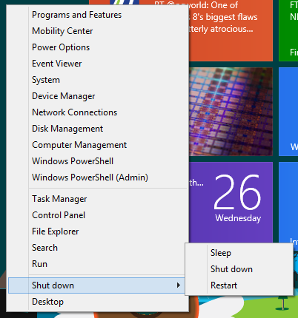
There are changes on the Start Screen itself. Two new tile sizes are available. The larger size can be used by the Weather app to show more weather, or smaller sizes can be grouped together. For example: the Microsoft Office’s Word, Excel, PowerPoint and Note.

In the screenshot below you can see the new sizes. In the upper right corner are 4 apps grouped together while in the middle is the large weather tile.

Internet Explorer has also been updated. The version downloaded with 8.1 is IE11. And last but not least, the screens can be resized to different sizes, up to four screens instead the only two ways the Windows 8 has.

The Start Button that shows up in lower left corner of the desktop screen just lets you get back to the Start Screen.

I have just successfully installed Windows 8.1 on my lap top as a dual boot so stay tuned for next month’s more detailed information and personal experiences.

